STUDENT ID: 22424253
ASTA 607: COMPUTATIONAL STATISTICS I
END OF FIRST SEMESTER EXAMS
QUESTION 1.
library(MASS)
#### a
?crabs
Results
The crabs data frame has 200 rows and 8 columns, describing 5 morphological measurements on 50 crabs each of two colour forms and both sexes, of the species Leptograpsus variegatus collected at Fremantle, W. Australia..
#### b
View(crabs)
str(crabs)
Results
data.frame': 200 obs. of 8 variables.

####c
OP1<-table(crabs$sp,crabs$sex)
Results
OP1<-table(crabs$sp,crabs$sex)
OP1
F M
B 50 50
O 50 50
#### d
barplot(OP1, main = "Barchart of group composition",
xlab = "Sex", ylab="Frequency",
beside = T)
Results
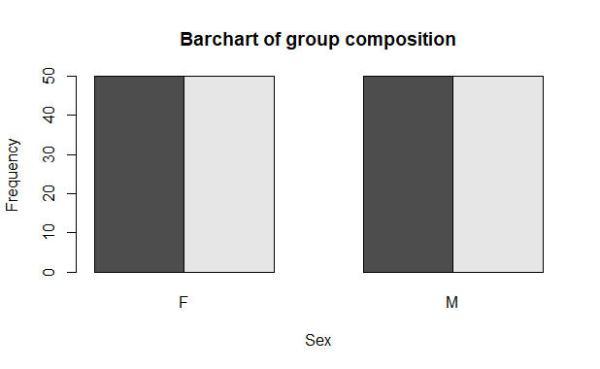

e. From the diagram above, the dataset is balanced across all four groups .

QUESTION 2.
#### QUESTION 2
### a
boxplot(BD~sex + sp, data = crabs
, col= c("green", "yellow", "red","purple"))

## comparing the central tendency and variability
describeBy(crabs$BD, group=crabs$sp,
mat= T)

describeBy(crabs$BD, group=crabs$sex,
mat= T)

Result
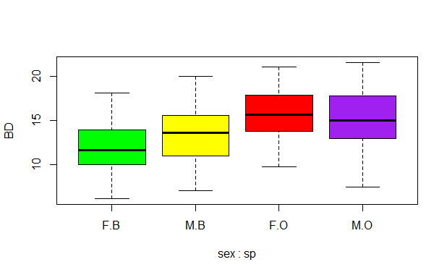
From the diagram above, there were no outliers found in any of the four groups.
The mean body depth (BD) of males is greater than that of females, and the variability of males is also greater than that of females. The mean BD of the blue species was lower than that of the orange species.

QUESTION 3.
### a
par(mar=c(4,4,1,1))
par(mfrow=c(1,2))
hist(crabs$CL[crabs$sp=="B"],col = "blue",
main=" Histogram of B specie",xlab="Specie B")
hist(crabs$CL[crabs$sp=="O"],col = "Yellow",
main=" Histogram of O specie",xlab="Specie O")
Results

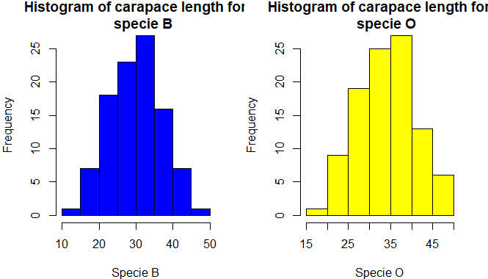

b. The Diagram above show the distribution of the different species. It can be seen that most of the observations are centered for specie B and that, the distribution of species B is symmetric. Also just a few observation can be found at fa the distribution of Specie O is slightly negatively skewed.

QUESTION 4
## mean of FL, RW, CL, CW and BD for species
meanFLB<- mean(crabs$FL[crabs$sp=="B"])
meanFLB
meanFLO<- mean(crabs$FL[crabs$sp=="O"])
meanFLO
meanCLB<- mean(crabs$CL[crabs$sp=="B"])
meanCLB
meanCLO<-mean(crabs$CL[crabs$sp=="O"])
meanCLO
meanRWB<-mean(crabs$RW[crabs$sp=="B"])
meanRWB
meanRWO<-mean(crabs$RW[crabs$sp=="O"])
meanRWO
meanCWB<-mean(crabs$CW[crabs$sp=="B"])
meanCWB
meanCWO<-mean(crabs$CW[crabs$sp=="O"])
meanCWO
meanBDB<-mean(crabs$BD[crabs$sp=="B"])
meanBDB
meanBDO<-mean(crabs$BD[crabs$sp=="O"])
meanBDO

####### mean of FL, RW, CL, CW and BD for sex
meanFLM<- mean(crabs$FL[crabs$sex=="M"])
meanFLM
meanFLF<- mean(crabs$FL[crabs$sex=="F"])
meanFLF
meanCLM<- mean(crabs$CL[crabs$sex=="M"])
meanCLM
meanCLF<-mean(crabs$CL[crabs$sex=="F"])
meanCLF
meanRWM<-mean(crabs$RW[crabs$sex=="M"])
meanRWM
meanRWF<-mean(crabs$RW[crabs$sex=="F"])
meanRWF
meanCWM<-mean(crabs$CW[crabs$sex=="M"])
meanCWM
meanCWF<-mean(crabs$CW[crabs$sex=="M"])
meanCWF
meanBDM<-mean(crabs$BD[crabs$sex=="F"])
meanBDM
meanBDF<-mean(crabs$BD[crabs$sex=="F"])
meanBDF

QUESTION 5.
###Question 5
OP2 <- crabs[, c("FL", "RW", "CL", "CW", "BD")]
pairs(OP2,
main = "Pairwise Scatter Plot of Crab Measurements",
pch = 19,
col = "blue")
Results
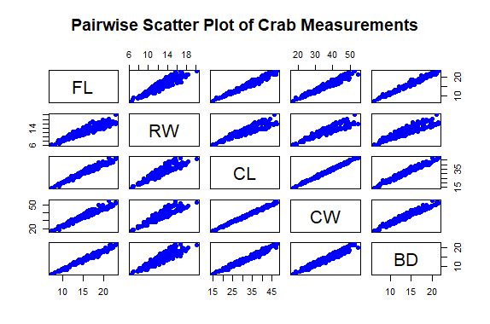
From the diagram above, it can be seen that there is a positive relationship between pairwise comparison of the five (5) morphological measurements. This suggests that there is a strong relationship between them.

Question 6
The crabs Dataset in R
The crabs dataset is available in the R package MASS. It is a dataset with 200 observations on 8 variables describing 5 morphological measurements on 50 crabs, each of two-color forms and both sexes, of the species Leptograpsus variegatus.
The table and diagram below show the distribution of the species and the sex in the dataset.
Speices | SEX
 | Male(M) | Female(F)
Blue(B) | 50 | 50
Orange(O) | 50 | 50

The diagram depicts that the dataset is balanced across the four groups. The mean comparison between the groups of sex and species showed that the mean body depth (BD) of males is greater than that of females, and the variability of males is also greater than that of females. The mean BD of the blue species was lower than that of the orange species.
The data showed that there is a strong pairwise relationship between the five(5) measurements, which suggests that an increase by a unit in one measurement causes and increament in the other. The diagram below shows a pairwise relationship



